Role Of Serum Biomarkers In Detection OF Pulmonary Hypertension In Interstitial Lung Diseases
Abstract:
Background: Interstitial lung diseases (ILDs) are chronic, progressive disorders that can be complicated by pulmonary hypertension (PH), particularly Group 3 PH, which significantly worsens prognosis. Early diagnosis of PH in ILD is crucial challenging, often requiring invasive procedures like right heart catheterization. Thus, the use of serum biomarkers may offer a valuable, non-invasive alternative. Objective: The objective of this investigation to evaluate the diagnostic utility of three serum biomarkers NT-proBNP, cardiac Troponin-T, and uric acid in detecting PH among ILD patients. Methods: A total of 55 ILD cases have been evaluated and separated into 2 groups: Group I (29 cases) with no/low echocardiographic probability of PH, and Group II (26 cases) with intermediate/high probability of PH. All patients subjected to full clinical assessment, (spirometry), arterial blood gas, high-resolution CT, echocardiography, and measurement of the (NT-proBNP, troponin and serum uric a`), RT Heart Catheterization to group II. Results: NT-proBNP, Troponin-T, and uric a` levels were significantly elevated in Group II. NT-proBNP had the best diagnostic performance (AUC = 0.886) with 84% sensitivity and 83.3% specificity at a cut-off of 89 picogram per milliliter. Uric acid and Troponin-T also showed good diagnostic utility (AUC = 0.853 and 0.798, correspondingly). All three biomarkers correlated positively with right ventricular systolic pressure (RVSP) & pulmonary artery systolic pressure (PASP). Conclusion: NT-proBNP, Troponin-T, and uric acid are promising non-invasive biomarkers for identifying PH in ILD cases. NT-proBNP, in particular, demonstrated the highest diagnostic accuracy.
Key words: Pulmonary hypertension; interstitial lung diseases; biomarkers; echocardiography; Right heart catheterization
INTRODUCTION
Interstitial lung disease is a comprehensive term that includes many lung disorders leading to fibrotic damage of the lung parenchyma ⁽¹⁾. PH is currently distinguished by a mean pulmonary arterial pressure over twenty millimeters of mercury at rest. Pulmonary arterial hypertension (PAH) is defined by a pulmonary vascular resistance (PVR) exceeding 2 Wood Units and a pulmonary arterial wedge pressure of 15 millimeters of mercury or less ⁽²⁾. The primary factor influencing all causes of death is the onset of pulmonary hypertension (PH) owing to ILD, making PH as a crucial element in the management of ILD cases. PH is defined by a persistent elevation in lung pressure due to significant pulmonary vascular remodeling and a reduction in capillary density ⁽³⁾. Consequently, biomarkers are justified as primary screening tools. Several biomarkers for pulmonary hypertension (PH) have been suggested, such as NT-pro brain natriuretic peptide (NT-proBNP) & troponin-T, both of which are correlated with elevated death in pulmonary arterial hypertension (PAH) ⁽⁴⁾.
Aim of this work
To investigate the role of serum NT-proBNP, troponin-T and uric acid in the detection of pulmonary hypertension in interstial lung diseases.
Patients and Methods:
Interventional cross-sectional research has been carried out on 55 adult patients diagnosed with interstitial lung disease (ILD) at Benha and Cairo University Hospitals between December 2022 and December 2024. The study protocol has been permitted by the Research Ethics Committees of both Benha and Cairo University Hospitals. Written informed consent has been gathered from all participants, following permission by Benha ethics committee with ethical approval code number: {M.D.9.12.2022}
Methods
Inclusion Criteria: patients Aged more than eighteen years, with written informed consent, Diagnosis of ILD based on ATS/ERS guidelines (2022) through clinical evaluation, HRCT, pulmonary function tests, bronchoscopy, and/or lung biopsy as needed ⁽⁵⁾.
Exclusion Criteria: patients with presence of left-sided heart failure, and patients with chronic kidney disease.
Patients have been classified into two groups with regard to the 2022 ESC/ERS echocardiographic criteria for pulmonary hypertension (PH): Group I (n=29) with no / low probability, and Group II (n=26) with intermediate or high probability confirmed by right heart catheterization. All patients undergone comprehensive clinical evaluation, pulmonary function testing (spirometry per ATS 2017) ^{(2,6)}, chest radiography, high-resolution computed tomography (HRCT), transthoracic echocardiography, and laboratory measurements including serum NT-proBNP (ELISA), troponin-T, and uric acid.
Serum NT-proBNP: Quantitative assessment of serum NT-proBNP with the ELISA assay as the primary approach. Utilizing the Kits provided by Shanghai Korain Biotech Co., Ltd, Cat. No E1239Hu.
Echocardiography: Utilizing a Philips EPIQ 7C device with the S5-1 probe for evaluation of the next.
Evaluation of the right side of the heart:
Evaluation of pulmonary hypertension possibility (in accordance with the 2022 ESC/ERS Guidelines) ⁽²⁾
Estimated systolic pulmonary artery pressure (ESPAP), Tricuspid regurge velocity (TRV), additional echocardiographic signs indicative of Pulmonary hypertension ⁽²⁾, & determination of possibility of PH to low, intermediate & high ⁽²⁾.
Evaluation of the left side of the heart:
Right heart catheterization (RHC):
Cases identified as having an intermediate to elevated probability of pulmonary hypertension based on echocardiographic criteria have undergone right heart catheterization utilizing a "Swan-Ganz catheter: TD Torque-Line Catheter, 7F, 4 lumen, 110 centimeters, heparin-coated, intended by intensive care unit Medical, the United States of America to verify the diagnosis & evaluate hemodynamic features and the degree of pulmonary artery pressure.
Procedures: Upon obtaining consent, the catheter & cases have been prepared through unpacking the catheter, flushing & testing the ports under strict sterile conditions, preparing the pressure follow up & transducer, sterilizing the area of puncture using povidone iodine solution & inserting the introducer sheath into the chosen vein The system is calibrated and zeroed at a reference point aligned with the fourth intercostal space at the mid-axillary line, which corresponds to the level of the left atrium..
Insertion of swan ganz catheter: The curvature of the catheter's packing is utilized to aid in its navigation towards the tricuspid valve. Observe alterations in the pressure waveform linked to the distal port during catheter advancement. The balloon is gradually inflated with air until the catheter reaches right atrium at around the twenty-centimeter mark, facilitating blood flow to guide the catheter into the correct pathway to the pulmonary artery (PA) for the measurement of pulmonary artery wedge pressure (PAWP). After obtaining the PAWP, ensure the pulmonary artery wedge pressure pattern is consistent through deflating the balloon & restoring PA pressure waves, followed by obtaining a mixed central venous sample via the catheter's side port.
Measurements: We calculated: The diastolic, systolic & mean pressures of right ventricle, PA, & RA then PAWP & Mixed central venous O2 saturation (SvO2)
Cardiac output (CO) has been measured utilizing direct Fick method ⁽⁷⁾.

CO = VO2 / (Ca - Cv) ⁽⁷⁾
*VO2 total oxygen consumption (milliliters per minute) *CO cardiac output (liter pr minute)
* Cv & Ca the venous & arterial oxygen content (milliliters per minute)
Cardiac index (CI) is measured as

= CO/BSA ⁽⁷⁾
*CO cardiac output (liter per minute),
*CI cardiac index (liter per minute per meter square),
*BSA body surface area (meter square
PVR is determined as PVR= (mPAP-PAWP)/CO ⁽²⁾
*PVR pulmonary vascular resistance (wood unit)
* mPAP mean pulmonary arterial pressure (millimeters of mercury)
*PAWP pulmonary artery wedge pressure (millimeters of mercury)
data analysis was performed utilizing SPSS v27 IBM, Armonk, New York, United States 2020, applying appropriate parametric/non-parametric tests, ROC curve analysis, and multivariate regression modeling to assess PH predictors. Statistical significance has been established at p-value under 0.05 ^{(8).}

RESULTS

Demographic and Clinical Characteristics
This study enrolled 55 patients diagnosed with interstitial lung disease (ILD). The mean age was 47 ± 13 years, & the majority were women (81.8%). A history of allergen exposure was reported in 63.6%, while only 14.5% were smokers. The most common ILD subtype was hypersensitivity pneumonitis (63.6%), followed by sarcoidosis (12.7%), idiopathic pulmonary fibrosis (10.9%), and scleroderma (7.3%). Less frequent diagnoses included chronic granulomatous lung disease, post-COVID pulmonary affection, and pulmonary alveolar microlithiasis (each accounting for 1.8%), Table (1).

2. Echocardiographic Findings
Echocardiographic assessment revealed that 52.8% of cases have been classified as having no/low possibility of pulmonary hypertension (PH), 12.7% had intermediate probability, and 34.5% were considered high probability (Figure 1).

3. Right Heart Catheterization Parameters
Among cases who had right heart catheterization, the median and mean hemodynamic parameters were as follows (Table2):
- Mean right atrial pressure: 6 millimeters of mercury (range: 0–16)
- Mean right ventricular pressure (mRVP): 20 mmHg (range: 0–40)
- Pulmonary vascular resistance (PVR): 4.85 Wood units (range: 1.37–14.5)
- Cardiac output (CO): 4.69 ± 1.35 liter per minute
- Mixed venous oxygen saturation (SvO₂): 59.7 ± 14.1%
- Pulmonary capillary wedge pressure (PCWP): median 9 millimeters of mercury (range: 2–14)
- Mean pulmonary artery pressure (mPAP): median 32 millimeters of mercury (range: 17–74)
- Cardiac index: median 3 L/min/m² (range: 1.27–5.8)
- Body surface area (BSA): 1.78 ± 0.34 m²

4. Serum Biomarkers According to Echocardiographic Probability of PH
Significantly elevated serum levels of uric acid, troponin, and ProBNP were observed in the moderate-to-high PH probability group compared to the no/low group:
- Uric acid: Median 7.15 mg/dL (range: 4.6–12) vs. 5 mg/dL (range: 2.4–9); P < 0.001
- Troponin: Median 20 ng/mL (range: 0.003–155) vs. 0.05 ng/mL (range: 0.001–12); P < 0.001
- ProBNP: Median 1918 pg/mL (range: 70–3800) vs. 50 pg/mL (range: 5–900); P < 0.001
Other laboratory values including urea (P = 0.431), creatinine (P -value equal 0.066), ALT (P = 0.102), AST (P = 0.505), and bilirubin (P = 0.696) illustrated a statistically insignificant variances among the groups (Table 3, Figure 2).

5. Diagnostic Performance of Biomarkers for Moderate-to-High PH Probability
a.UricAcid:
ROC analysis illustrated an area under the curve (AUC) of 0.818 (ninety-five percent CI: 0.704–0.932), indicating good predictive ability. A cutoff value >5.8 mg/dL showed a sensitivity of 92.31%, specificity of 68.97%, positive predictive value (PPV) of 72.7%, and negative predictive value (NPV) of 90.9% (Table 4, Figure 3).
b.Troponin:
ROC curve analysis illustrated an AUC of 0.880 (ninety-five percent CI: 0.782–0.978), denoting excellent discriminatory performance. A cutoff value >7 ng/mL provided a sensitivity of 73.08%, specificity of 96.55%, PPV of 96.55%, and NPV of 90% (Table 5, Figure 4).
c.ProBNP:
The ProBNP ROC analysis yielded an AUC of 0.946 (ninety-five percent CI: 0.893–0.998), suggesting outstanding diagnostic capability. A cutoff >89 pg/mL resulted in a sensitivity of 92.31%, specificity of 82.76%, PPV of 82.8%, and NPV of 92.3% (Table 6, Figure 5)

DISCUSSI0N
PH is a prevalent and serious complication of interstitial lung diseases, specifically idiopathic pulmonary fibrosis (IPF) and connective tissue disease (CTD)-associated ILDs. Other ILDs like hypersensitivity pneumonitis & sarcoidosis, can also be complicated by PH. Across these conditions, PH is related to diminished exercise capacity, reduced functional status, and poor outcome⁽⁹⁾.
Although right heart catheterization is still the gold standard for identifying PH & provides prognostically significant hemodynamic parameters, it is invasive, expensive, and typically limited to specialized centers ⁽¹⁰⁾. This underscores the need for non-invasive biomarkers as initial screening tools for early PH detection.
Among proposed biomarkers, NT-proBNP and troponin-T have been linked with adverse outcomes and elevated death in cases with PH) ⁽¹¹⁾.

Patient Characteristics and ILD Patterns
As illustrated in Table (1), the mean age of our cohort was 47 ± 13 years, with a marked female predominance (81.8%). Allergen exposure was reported in 61.8%, and 14.5% were smokers. HP emerged as the most common diagnosis (63.6%), followed by sarcoidosis (12.7%), IPF (10.9%), scleroderma (7.3%), and (1.8%) for each of chronic granulomatous lung disease, post-COVID pulmonary affection, and pulmonary alveolar microlithiasis.
- A high prevalence of hypersensitivity pneumonitis (HP) and a female predominance among ILD patients was observed, these results are in line with several Egyptian reperches as (Akl et al 2017).⁽¹²⁾ conducted a demographic study of hypersensitivity pneumonitis in egypt: a single center experience, with a significant female predominance attributed to domestic bird exposure. Similarly, Abd El-Kareem et al. (2017) ⁽¹³⁾ reported that 90.7% of HP patients were female, with 20.9% having a history of bird contact. Additionally, Akl et al. (2019) ⁽¹⁴⁾ observed that 85% of HP patients were female, with 80% reporting bird-raising activities. These studies highlight the significant role of environmental factors, particularly domestic bird exposure, in the development of HP among Egyptian women. In contrast, international studies such as Parikh et al. (2022) ⁽¹⁵⁾ and Ruocco et al. (2015) ⁽¹⁶⁾ identified idiopathic pulmonary fibrosis as the most common ILD subtype, predominantly affecting older males. This discrepancy underscores the influence of region-specific environmental exposures and sociocultural practices on ILD patterns. In Egypt, women's involvement in domestic poultry farming increases their risk of developing HP. These findings emphasize the importance of considering local epidemiological data when diagnosing and managing ILD.
Our demographics are consistent with Corte et al. (2014) ⁽¹⁷⁾, who also reported a similar mean age and female predominance in ILD patients evaluated for NT-proBNP. In contrast, Andersen et al. (2012) ⁽¹⁸⁾ described a more balanced or male-dominant population, often with fibrotic ILDs like IPF.
The low prevalence of smoking (14.5%) in our study is notably lower than in Nathan et al. (2008) ⁽¹⁹⁾, where many IPF patients were current or former smokers. This may relate to the predominance of HP and the female composition of our cohort. Moreover, smoking is known to modulate oxidative stress and inflammation, potentially influencing biomarker levels, such as serum uric acid and troponin.

Hemodynamic Parameters (Table 2)
- mRAP: Our median right atrial pressure was 6 mmHg, suggesting early right heart strain. This is in line with Andersen et al. (2012) ⁽¹⁸⁾, who emphasized elevated mRAP as a surrogate of RV dysfunction.
- PVR: A median PVR of 4.85 Wood units denotes moderate-to-severe elevation, similar to levels reported in ILD-PH cohorts and consistent with disease progression (Andersen et al., 2012) ⁽¹⁸⁾.
- mPAP: The mean mPAP of 32 mmHg indicates moderate PH. Humbert et al. (2006) ⁽²⁰⁾ and D’Alonzo et al. (1991) ⁽²¹⁾ described similar mPAP Zhang J, Zhao YX, Wang J, et al. Serum uric acid levels and pulmonary hypertension in patients with chronic obstructive pulmonary disease. Clin Respir J. 2016;10(6):781–9. in ILD-associated PH, confirming significant vascular involvement.
- CO and CI: Reduced values were comparable to Andersen’s findings, signifying compromised RV function in PH patients ⁽²⁰⁾.
- SvO₂: Our mean SvO₂ was 59.7 ± 14.1%, suggestive of reduced oxygen delivery and increased peripheral extraction, consistent with PH pathophysiology.

Correlation Analyses (Figure 2)
- Uric Acid: Positively related to estimated PAP (r = 0.679, P-value under 0.001), ProBNP (r = 0.609), and troponin (r = 0.343). Zhang et al. (2016) ⁽²²⁾ reported similar findings, highlighting uric a` as a marker of oxidative stress and endothelial dysfunction in PH.
- Troponin: Showed strong correlations with ProBNP (r = 0.603), estimated PAP (r = 0.652), A–a gradient (r = 0.487), and inverse correlations with PaO₂ and SaO₂. These results align with Benza et al. (2010) ⁽²³⁾ and Tonelli et al. (2014) ⁽²⁴⁾, who recognized troponin as a marker of RV strain.
- ProBNP: Showed the highest correlation with estimated PAP (r = 0.794), reaffirming its value in identifying PH severity. Prior studies (Leuchte et al., 2007) ⁽²⁵⁾ similarly demonstrated strong associations with RV dysfunction.

Biomarker Findings
As shown in Table (3), median uric acid was 5 mg/dL (range: 2.4–9) in low probability while in high probability 7.1mg/dl (range: 4.6–12), troponin was .05 ng/mL (range: 0.001–12)in low probability while in high probability 20 ng/l (range: .003–155), and NT-proBNP was 50 pg/mL mg/dL (range: 5–900) in low probability while in high probability 1918mg/dl (range: 70–3800) (range: 5–3800). Elevated uric acid and troponin levels support their association with PH in ILD, while the relatively low median NT-proBNP may indicate early disease stages or a less severe PH burden. Biomarker interpretation should be integrated with clinical and echocardiographic data due to multifactorial influences.

Diagnostic Performance (Tables 4–6, Figures 3–5)
- Uric Acid: AUC of 0.818; sensitivity 92.31% at cutoff >5.8 mg/dL. This supports Izhakian,et al. (2021) ⁽²⁶⁾, who found uric acid useful for early detection but with moderate specificity (68.97%), limiting its standalone diagnostic utility.
- Troponin: AUC of 0.880; excellent specificity (96.55%) at cutoff >7 pg/mL. This agrees with findings from Nathan et al. (2008) ⁽¹⁹⁾, highlighting its role in confirming PH due to RV myocardial injury.
- ProBNP: Showed the best overall performance with an AUC of 0.946, sensitivity of 92.31%, and specificity of 82.76% at a cutoff >89 pg/mL. This is consistent with Galie et al. (2009) ⁽⁹⁾ and Egyptian data from Izhakian,et al. (2024) ⁽²⁶⁾, confirming its clinical utility in early PH detection.

Conclusions
This study highlights the diagnostic potential of serum biomarkers particularly NT-proBNP, troponin-T, and uric acid- in identifying pulmonary hypertension in ILD patients. Among these, NT-proBNP exhibited the highest diagnostic accuracy and can be reliably used as a screening tool. Troponin and uric acid also demonstrated significant predictive value and may serve as adjuncts in identifying at-risk patients.
Integrating these biomarkers into routine assessment protocols may improve early detection, optimize patient selection for confirmatory RHC, and facilitate earlier interventions—ultimately improving outcomes for ILD patients at risk of PH.
abbreviations
CI | Cardiac Index
CO | Cardiac Output
ILD | Interstial lung disease
ESPAP | Estimated Systolic Pulmonary Artery Pressure
FVC | Forced Vital Capacity
DLCO | Diffusing Capacity of the Lung for Carbon Monoxide
NT-proBNP | N-terminal pro–B-type Natriuretic Peptide
CTD | Connective Tissue Disease
IPF | Idiopathic Pulmonary Fibrosis  European Society of Cardiology / European Respiratory Society
  ESC/ERS
mPAP | Mean Pulmonary Artery Pressure
PAWP | Pulmonary Artery Wedge Pressure
PA | Pulmonary Artery
PH | Pulmonary Hypertension
Pg | Picogram
PVR | Pulmonary Vascular Resistance
PPH | Primary Pulmonary Hypertension
RV | Right Ventricle
TNF | Tumer Necrosis Factor
RA | Right Atrium
RHC | Right Heart Catheterization
TRV | Tricuspid Regurge Velocity
WU | Wood Unit
Tnt | tropnin
6MWD | Six-Minute Walk Distance
ABG  HRCT | Arterial blood gases  High resolution conventional tomography

DECLARATIONS
Ethics approval & consent to participate: Written informed consent has been gathered from all cases or gradians; the Benha university ethics committee provide its permission to the research with ethical approval code number: (MD 9-12-2022)

Consent for publication: not applicable
Availability of information & material: the information will be available to the journal & reviewers from the corresponding author upon reasonable request
Conflict of interest: The authors affirm no conflict of interest.
Sources of funding: This investigation didn’t receive any particular grant from funding agencies in the public, commercial, or not-for-profit sectors.
Author contribution: Authors provided equal contributions to the research.
Acknowledgments: not applicable

Referenceses
- King TE, Pardo A, Selman M. Idiopathic pulmonary fibrosis. The Lancet. 2011 Dec 3;378(9807):1949-61.
- Galiè N, Humbert M, Vachiery JL, Gibbs S, Lang I, Torbicki A, et al. 2022 ESC/ERS Guidelines for the diagnosis and treatment of pulmonary hypertension. Eur Heart J. 2022;43(38):3618–3731.
- Thenappan T, Ormiston ML, Ryan JJ, Archer SL. Pulmonary arterial hypertension: pathogenesis and clinical management. Bmj. 2018 Mar 14;360.
- Nagaya N, Nishikimi T, Okano Y, Uematsu M, Satoh T, Kyotani S, et al. Plasma brain natriuretic peptide levels increase in proportion to the extent of right ventricular dysfunction in pulmonary hypertension. Journal of the American College of Cardiology. 1998 Jan;31(1):202-8.
- Raghu G, Remy-Jardin M, Richeldi L, Thomson CC, Inoue Y, Johkoh T, et al. Diagnosis of interstitial lung diseases: an official ATS/ERS clinical practice guideline. Am J Respir Crit Care Med. 2022;205(5):e18–47.
- Graham BL, Steenbruggen I, Miller MR, Barjaktarevic IZ, Cooper BG, Hall GL, et al. Standardization of spirometry 2019 update. An official ATS/ERS technical statement. Am J Respir Crit Care Med. 2019;200(8):e70–e88.
- Hoeper MM, Bogaard HJ, Condliffe R, Frantz R, Khanna D, Kurzyna M, et al. Definitions and diagnosis of pulmonary hypertension. Journal of the American College of Cardiology. 2013 Dec 24;62(25S):D42-50.
- Peacock JL, Peacock PJ. Oxford handbook of medical statistics. Oxford university press; 2020 Jun 11.
- Galie N, Hoeper MM, Humbert M, Torbicki A, Vachiery JL, Barbera JA, et al. Guidelines for the diagnosis and treatment of pulmonary hypertension: the Task Force for the Diagnosis and Treatment of Pulmonary Hypertension of the European Society of Cardiology (ESC) and the European Respiratory Society (ERS), endorsed by the International Society of Heart and Lung Transplantation (ISHLT). European heart journal. 2009 Oct 1;30(20):2493-537.
- Hoeper MM, Lee SH, Voswinckel R, Palazzini M, Jais X, Marinelli A, et al. Complications of right heart catheterization procedures in patients with pulmonary hypertension in experienced centers. Journal of the American College of Cardiology. 2006 Dec 19;48(12):2546-52.
- Warwick G, Thomas PS, Yates DH. Biomarkers in pulmonary hypertension. European Respiratory Journal. 2008 Jul 31;32(2):503-12.
- Akl Y., Soliman Y., El-Korashy R., El-Hennawi Y. (2017): Demographic study of hypersensitivity pneumonitis in egypt: a single center experience. Am J Respir crit care Med, 195: A1566.
- Abd El-Kareem D, Akl YM, Nakhla GA, Elhindawi AA, Eltorky MA. Clinico-pathologic presentation of hypersensitivity pneumonitis in Egyptian patients: a multidisciplinary study. Multidisciplinary Respiratory Medicine. 2017 May 8;12(1):10.
- Akl M, Abdel Maksoud H, Ghanem M, El-Behedy RM. Pattern of interstitial lung diseases at Ain Shams University Hospitals: A retrospective study. Egypt J Chest Dis Tuberc. 2019;68(4):657–63
- Parikh R, Hoskere G, Das CJ, Gupta R, Sharma SK, Aggarwal AN, et al. Pulmonary hypertension in interstitial lung disease: prevalence, functional impairment and short-term outcomes. Lung India. 2022;39(3):218–24.
- Ruocco G, Terzi S, Agostoni P, Temporelli PL, Cattadori G, Opasich C, et al. Pulmonary hypertension in interstitial lung diseases: a retrospective national cohort. Clin Respir J. 2015;9(3):313–20.
- Corte TJ, Wort SJ, Wells AU, Nicholson AG, Hansell DM, Du Bois RM, et al. Pulmonary hypertension in idiopathic pulmonary fibrosis: a review. Sarcoidosis Vasc Diffuse Lung Dis. 2014;31(1):3–10.
- Andersen CU, Mellemkjær S, Hilberg O, Nielsen-Kudsk JE, Simonsen U, Bendstrup E. Pulmonary hypertension in interstitial lung disease: prevalence, prognosis and 6 min walk test. Respiratory medicine. 2012 Jun 1;106(6):875-82.
- Nathan SD, Shlobin OA, Barnett SD, Saggar R, Belperio JA, Ross DJ, et al. Right ventricular systolic pressure by echocardiography as a predictor of pulmonary hypertension in idiopathic pulmonary fibrosis. Respiratory medicine. 2008 Sep 1;102(9):1305-10.
- Humbert M, Sitbon O, Chaouat A, Bertocchi M, Habib G, Gressin V, et al. Pulmonary arterial hypertension in France: results from a national registry. American journal of respiratory and critical care medicine. 2006 May 1;173(9):1023-30.
- D'Alonzo GE, Barst RJ, Ayres SM, Bergofsky EH, Brundage BH, Detre KM, et al. Survival in patients with primary pulmonary hypertension: results from a national prospective registry. Annals of internal medicine. 1991 Sep 1;115(5):343-9.
- Zhang J, Zhao YX, Wang J, et al. Serum uric acid levels and pulmonary hypertension in patients with chronic obstructive pulmonary disease. Clin Respir J. 2016;10(6):781–9.
- Benza RL, Miller DP, Gomberg-Maitland M, Frantz RP, Foreman AJ, Coffey CS, et al. Predicting survival in pulmonary arterial hypertension: insights from the registry to evaluate early and long-term pulmonary arterial hypertension disease management (REVEAL). Circulation. 2010 Jul 13;122(2):164-72
- Tonelli AR, Plana JC, Heresi GA, Tang WH, Dweik RA, Bair N, et al. Prognostic value of troponin I in patients with pulmonary arterial hypertension. J Am Coll Cardiol. 2014;63(7):682–9.
- Leuchte HH, El Nounou M, Tuerpe JC, Hartmann B, Baumgartner RA, Vogeser M, et al. N-terminal pro-brain natriuretic peptide and renal insufficiency as predictors of mortality in pulmonary hypertension. Chest. 2007 Feb 1;131(2):402-9.
- Izhakian S, Gorenshtein A, Engelstein H, Freidkin L, Rosengarten D, Eldar O, Kramer MR.: Utility of serum uric acid levels in excluding pulmonary hypertension in severe chronic lung disease: insights from a tertiary care center. Clin Exp Med. 2024;24(1):220.

Table1: baseline characteristics
Baseline characteristics (n=55)
Age (years) | Mean ±SD | 47 ±13
Sex
Males | n (%) | 10 (18.2)
Females | n (%) | 45 (81.8)
Exposure to allergen | n (%) | 34 (61.8)
Smoking | n (%) | 8 (14.5)
Diagnosis
HP | n (%) | 35 (63.6)
IPF | n (%) | 6 (10.9)
Chronic granulomatous lung | n (%) | 1 (1.8)
Sarcoidosis | n (%) | 7 (12.7)
Scleroderma | n (%) | 4 (7.3)
Post COVID | n (%) | 1 (1.8)
PA Microlithiasis | n (%) | 1 (1.8)

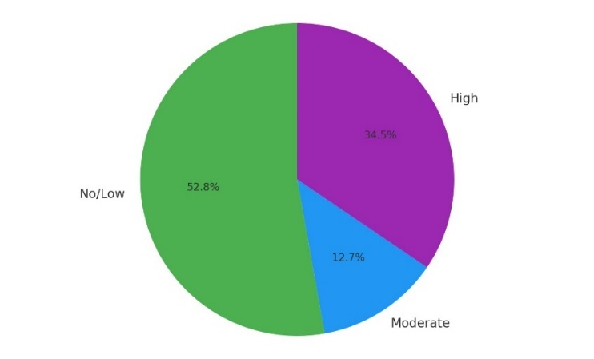
Figure 1: Distribution of echo probability of PHTN among the studied participants.

Table 2: Right sided heart catheter parameters among the studied participants.
Right sided heart catheter parameters (n=26)
mRAP (mmHg) | Median (range) | 6 (0 – 16)
mRVP (mmHg) | Median (range) | 20 (0 – 40)
PVR (Wood units) | Median (range) | 4.85 (1.37 – 14.5)
CO (L/min) | Mean ±SD | 4.685 ±1.353
SVO2 (%) | Mean ±SD | 59.7 ±14.1%.
BSA (m²) | Mean ±SD | 1.779 ±0.338
Wedge(mmHg) | Median (range) | 9 (2 – 14) mmHg
mPAP(mmHg) | Median (range) | 32 (17 – 74) mmHg
CI (L/min/m²) | Median (range) | 3 (1.27 – 5.8)
mRAP: Mean right atrial pressure; mRVP: Mean right ventricular pressure; PVR: Pulmonary vascular resistance; CO: Cardiac output; SVO₂: Mixed venous oxygen saturation; BSA: Body surface area; mPAP: Mean pulmonary arterial pressure; CI: Cardiac index.

Table3: serum biomarkers according to echocardiographic probability of PHTN.
 |  | Echo probability |  | P-value
 |  | No-Low (n=29) | Mod-High (n=26) | P-value
Uric Acid (mg/dL) | Median (range) | 5 (2.4 - 9) | 7.15 (4.6 - 12) | <0.001*
Troponin (ng/L) | Median (range) | 0.05 (0.001 - 12) | 20 (0.003 - 155) | <0.001*
Pro BNP (pg/mL) | Median (range) | 50 (5 - 900) | 1918 (70 - 3800) | <0.001*

Figure 2: Different parameters according to echo probability of PHTN. A. Uric Acid, B. Troponin, C. Pro BNP.

Table4: ROC analysis for uric acid to predict moderate to high echo probability of PHTN.
ROC characteristics
AUC (95% CI) | 0.818 (0.704 – 0.932)
Best cutoff (mg/dl) | >5.8
Sensitivity | 92.31 %
Specificity | 68.97 %
PPV | 72.7 %
NPV | 90.9%
P-value | <0.001*
*Significant at P < 0.05; AUC: Area under the curve; 95% CI: 95% confidence interval; PPV: Positive predictive value; NPV: Negative predictive value.

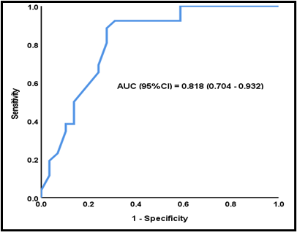
Figure 3: ROC analysis for uric acid to predict moderate to high echo probability.

Table 5: ROC analysis for troponin to predict moderate to high echo probability of PHTN.
ROC characteristics
AUC (95% CI) | 0.880 (0.782 – 0.978)
Best cutoff (ng/ml) | >7
Sensitivity | 73.08 %
Specificity | 96.55 %
PPV | 96.55%
NPV | 90 %
P-value | <0.001*
/*Significant at P < 0.05; AUC: Area under the curve; 95% CI: 95% confidence interval; PPV: Positive predictive value; NPV: Negative predictive value.

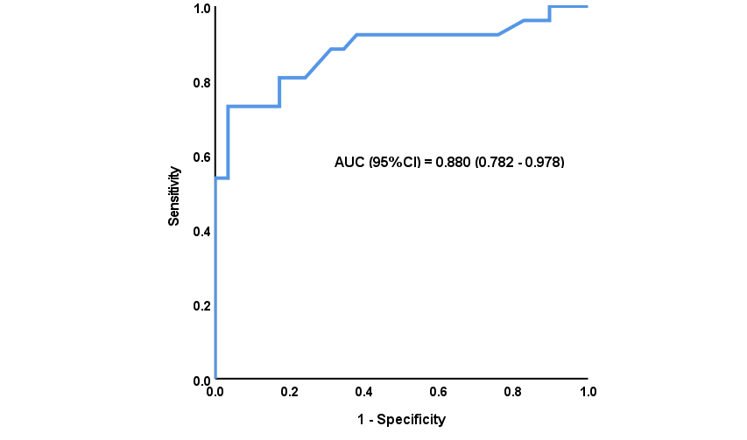 Figure 4: ROC analysis for troponin to predict moderate to high echo probability.
Table 6: ROC analysis for Pro BNP to predict moderate to high echo probability of PHTN.
ROC characteristics
AUC (95% CI) | 0.946 (0.893 – 0.998)
Best cutoff (Pg/ml) | >89
Sensitivity | 92.31 %
Specificity | 82.76 %
PPV | 82.8 %
NPV | 92.3 %
P-value | <0.001*
*Significant at P < 0.05; AUC: Area under the curve; 95% CI: 95% confidence interval; PPV: Positive predictive value; NPV: Negative predictive value.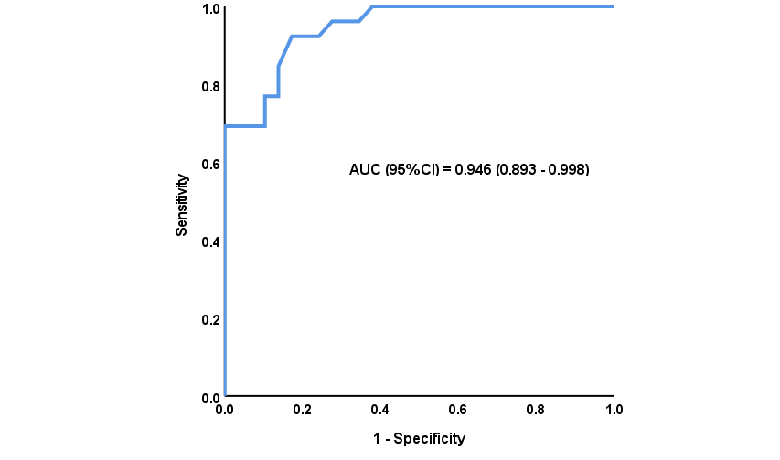 Figure 5: ROC analysis for Pro BNP to predict moderate to high echo probability.

